Order Of Service

Singing: Psalm 31—CW page 77

Reading: Psalm 119:161 - 168

Opening Hymn: TLH 436

Reading: Hebrews 10:32-39

Request Hymn: CW Supplement 749

Reading: Luke 14:15-24

Sermon Hymn: TLH 215

Sermon Text: Song Of Solomon 1:4a

Drawing & Running

Prayer

The Apostles’ Creed, TLH page 12

Holy Communion

The Lord's Prayer

The Blessing

Closing Hymn: TLH 50

* * * * * * * * * * *

Bible Study: Lambs: I Kings 3:16-28; Love Is Unselfish
Sheep: Proverbs 3:9-12
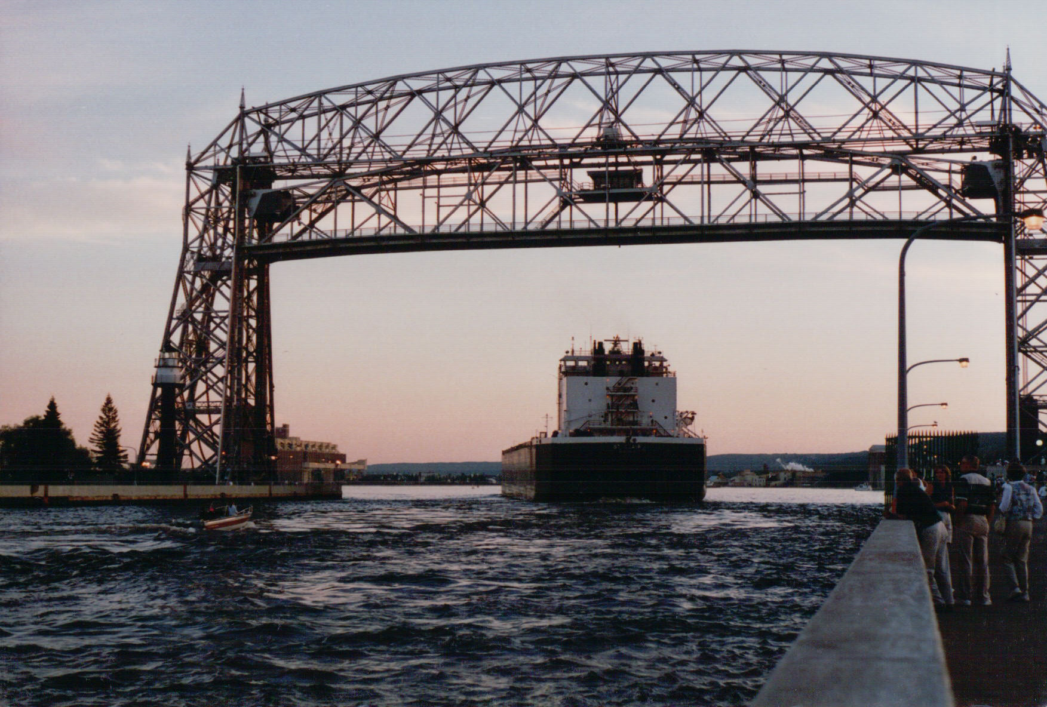

Zenith City Harbor

Water
Of
Life

14 June 2015

W A T E R O F L I F E

Independent Christian Church—Conservative Lutheran Doctrine

Worship Service: 9:30 a.m. Bible Study: 10:45 a.m.

Larry Cooper, Pastor E-Mail address:
111 N. Ridge Road lcooper@wateroflife.cc
Coon Valley, WI 54623 Web Site:
Phone: (608) 452-2105 www.wateroflife.cc

* * * * * * * * * * * * * * * * * * * * * * * * * * *

Sermon Text: Song Of Solomon 1:4a

Drawing & Running

* * * * * * * * * * * * * * * * * * * * * * * * * * *

4: Draw me, we will run after thee: . . . . .

Here in the opening words of verse 4 the Bride entreats the Bridegroom to “draw me”. The Father, Son, and Holy Spirit are all involved in this drawing of the Bride. God always makes the first move. Jesus mentioned the Father drawing his elect in John 6. The context of that chapter is greatly instructive. There is a tremendous downward progression. In the beginning of the chapter Jesus is followed by a great multitude. By the end of the chapter he is left with only a mere handful. We’ll look at a few of the details this morning. To start with, here are a few key passages:
John 6

:2 Jesus is followed by “a great multitude.”

:5-13 Jesus feeds the five thousand

:15 The people want to take Jesus by force and make him
their king. He left them, and went up into a mountain
alone.

:28-29—Question and Answer: “Then said they unto him, What shall we do, that we might work the works of God?
Jesus answered and said unto them, This is the work of God, that ye believe on him whom he hath sent.”

:41-42—The Jews murmur against Jesus: “The Jews then murmured at him, because he said, I am the bread which came down from heaven. And they said, Is not this Jesus, the son of Joseph, whose father and mother we know? how is it then that he saith, I came down from heaven?”

:43-44—Jesus responds: “Jesus therefore answered and said unto them, Murmur not among yourselves. No man can come to me, except the Father which hath sent me draw him: and I will raise him up at the last day.”

:60 & 66—Many leave Jesus: “Many therefore of his disciples, when they had heard this, said, This is an hard saying; who can hear it?”

“From that time many of his disciples went back, and walked no more with him.”

:67—Jesus puts a question to the twelve: “Then said Jesus unto the twelve, Will ye also go away?” History shows that there was one taker.

